1. Use Case Flow
   1. The User makes a request to compare the current state of the simulation (either the end or an arbitrary point from pausing it) to a previous state. Via the UI, the user provides a point in time between the start of the simulation and the current point. The UI submits the information to the simulation system, and the simulation system provides the UI with the metrics collected from that point in time to the UI. The UI adjusts its layout to accommodate for the new information and updates its display to show the user a comparison between the current state and the requested state.
2. Use Case Diagram

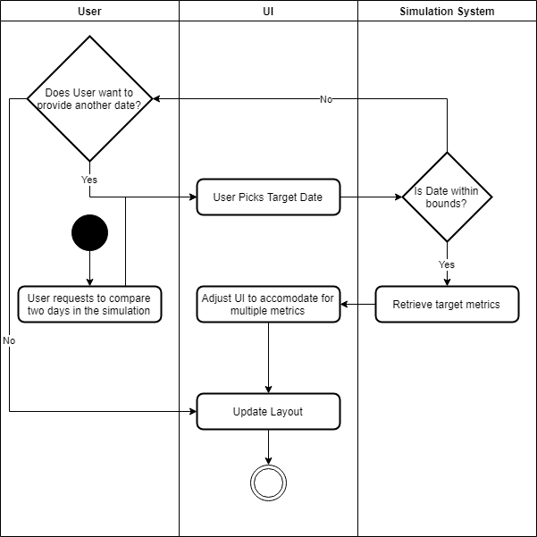

1. ERD

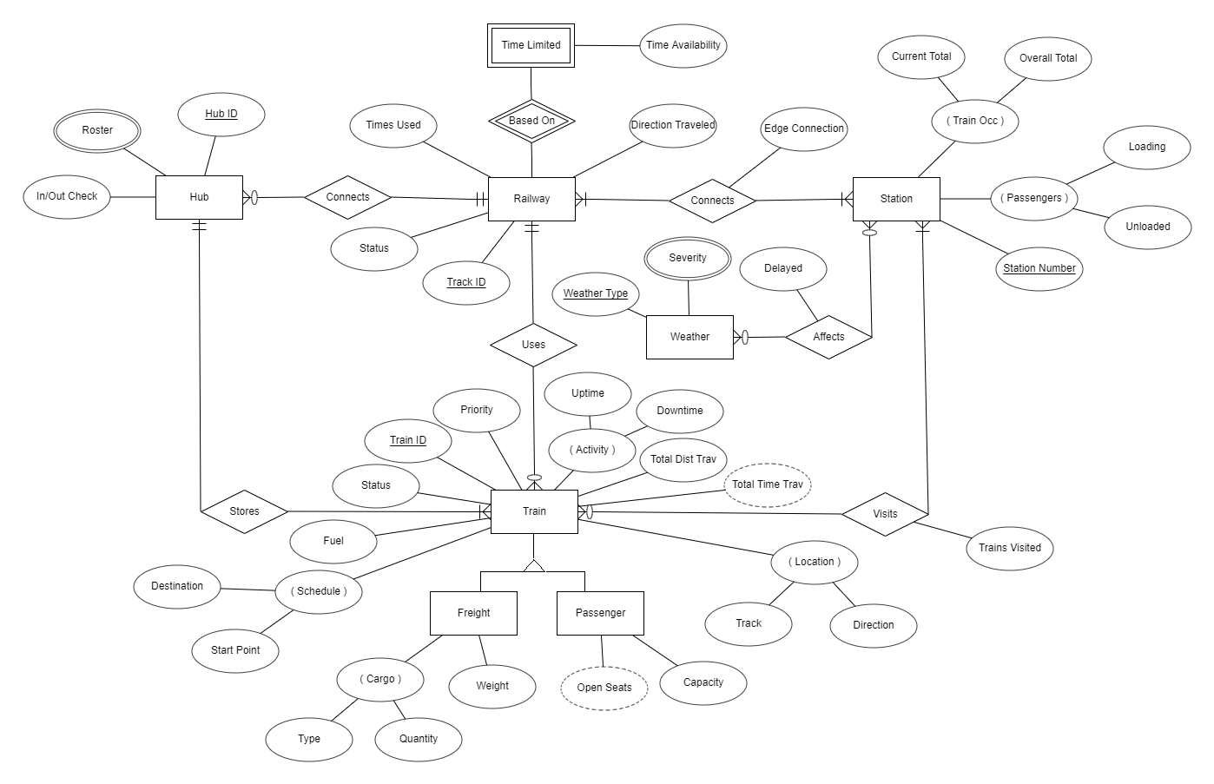

1. DFD
2. Communication Diagram

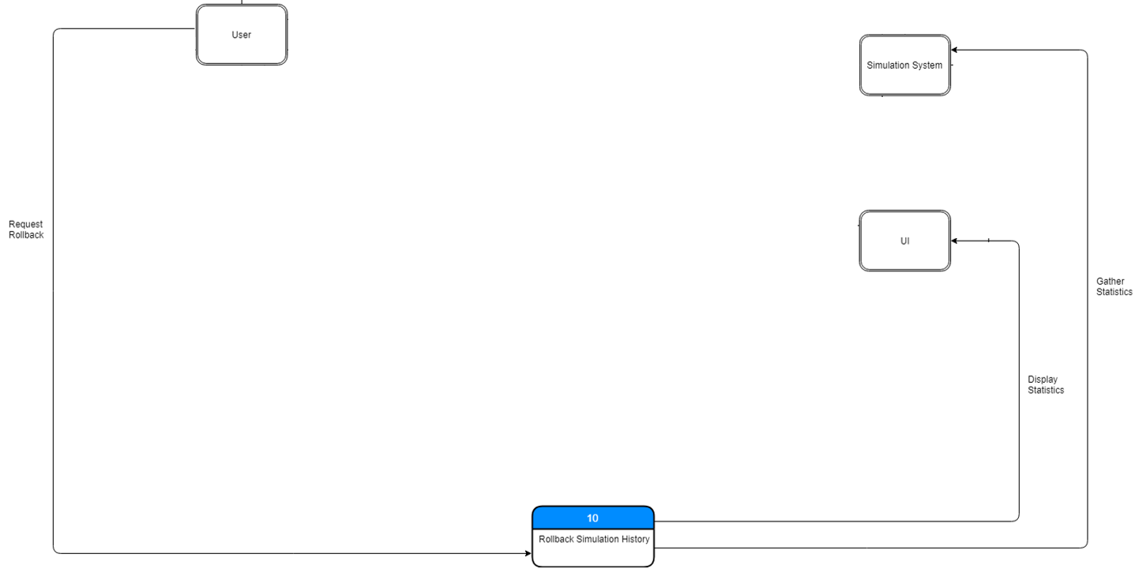

1. CRC Card
   1. N/A
2. Class Diagram

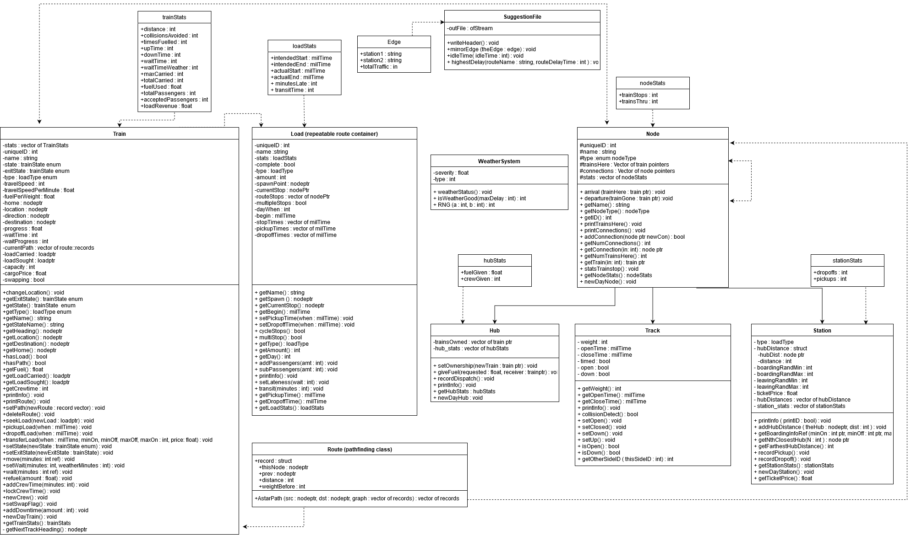

1. Architecture Diagram

N/A

1. Algorithm

1. Sequence Diagram
2. Code
3. Execution